In dbt (data build tool), artifacts refer to the outputs or results generated during the execution of dbt commands. These artifacts represent the transformed data, metadata, and other generated files that are produced as a result of running dbt in your project.

Here are some common artifacts generated by dbt:

1. Compiled SQL Queries: dbt takes your SQL code and compiles it into executable queries specific to your database. These compiled SQL queries are one of the primary artifacts generated by dbt.
2. Transformed Data: dbt performs transformations on your data based on the defined models and transformations in your dbt project. The transformed data, such as dimensional tables or aggregates, is another type of artifact produced by dbt.
3. Test Results: dbt allows you to define data tests to validate the quality and integrity of your data. When you run tests using dbt, the test results, including any errors or warnings, are generated as artifacts.
4. Documentation: dbt can generate documentation for your project, including descriptions of models, columns, and relationships. The generated documentation is also considered an artifact of the dbt process.
5. Compiled Graph: dbt creates a dependency graph that represents the relationships between models, sources, and transformations in your project. The compiled graph, which helps optimize the execution order of dbt commands, is another example of an artifact.

These artifacts are essential for understanding and working with your dbt project. They provide insights into the transformed data, the status of tests, the compiled SQL queries, and the project's structure.

By generating and managing these artifacts, dbt enables data engineers, analysts, and scientists to develop and maintain data pipelines, perform data transformations, and ensure data quality in a structured and reproducible manner.

**Artifacts**

When running dbt jobs, dbt Cloud generates and saves *artifacts*. You can use these artifacts, like manifest.json, catalog.json, and sources.json to power different aspects of dbt Cloud, namely: [dbt Docs](https://docs.getdbt.com/docs/collaborate/documentation) and [source freshness reporting](https://docs.getdbt.com/docs/build/sources#snapshotting-source-data-freshness).

**Create dbt Cloud Artifacts**[**​**](https://docs.getdbt.com/docs/deploy/artifacts#create-dbt-cloud-artifacts)

While running any job can produce artifacts, you should only associate one production job with a given project to produce the project's artifacts. You can designate this connection in the **Project details** page. To access this page, click the gear icon in the upper right, select **Account Settings**, select your project, and click **Edit** in the lower right. Under **Artifacts**, select the jobs you want to produce documentation and source freshness artifacts for.

[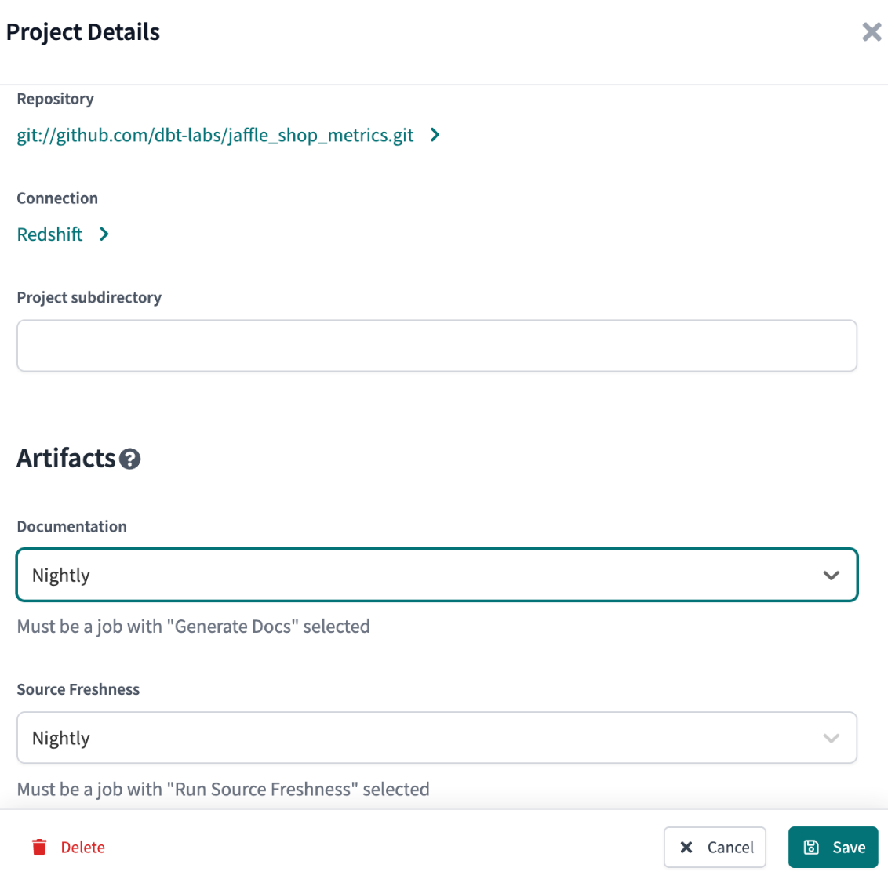](https://docs.getdbt.com/docs/deploy/artifacts)Configuring Artifacts

If you don't see your job listed, you might need to edit the job and select **Run source freshness** and **Generate docs on run**.

[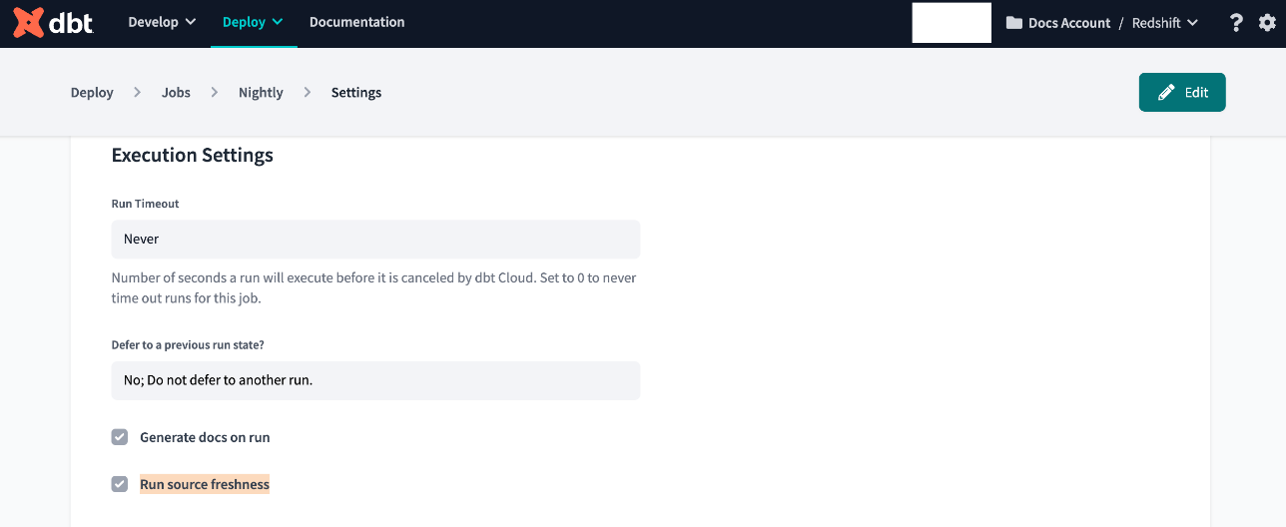](https://docs.getdbt.com/docs/deploy/artifacts)Editing the job to generate artifacts

When you add a production job to a project, dbt Cloud updates the content and provides links to the production documentation and source freshness artifacts it generated for that project. You can see these links by clicking **Deploy** in the upper left, selecting **Jobs**, and then selecting the production job. From the job page, you can select a specific run to see how artifacts were updated for that run only.

**Documentation**[**​**](https://docs.getdbt.com/docs/deploy/artifacts#documentation)

When set up, dbt Cloud updates the **Documentation** link in the upper left so it links to documentation for this job. This link always points to the latest version of the documentation for your account!

[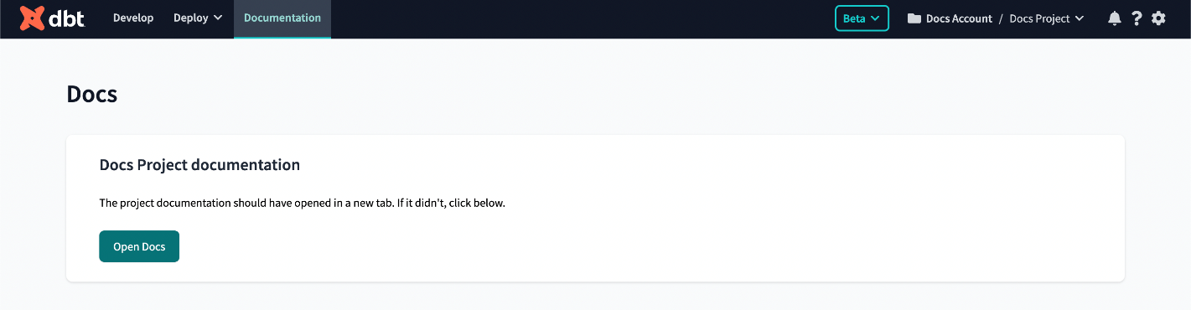](https://docs.getdbt.com/docs/deploy/artifacts)A link to the latest documentation for the selected job

**Source Freshness**[**​**](https://docs.getdbt.com/docs/deploy/artifacts#source-freshness)

As with Documentation, configuring a job for the Source Freshness artifact setting also updates the Data Sources link under **Deploy**. The new link points to the latest Source Freshness report for the selected job.

[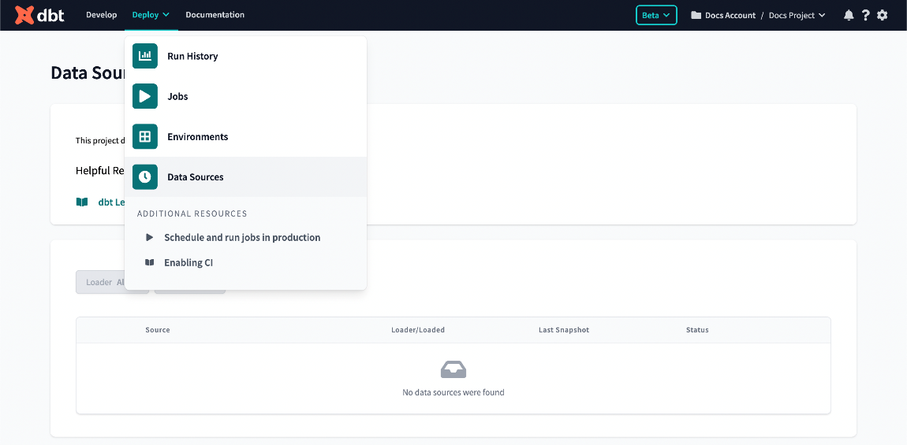](https://docs.getdbt.com/docs/deploy/artifacts)A link to the latest source freshness snapshot for the selected job